**Creating Microservices for account and loan**

In this hands on exercises, we will create two microservices for a bank. One microservice for handing accounts and one for handling loans.

Each microservice will be a specific independent Spring RESTful Webservice maven project having it's own pom.xml. The only difference is that, instead of having both account and loan as a single application, it is split into two different applications. These webservices will be a simple service without any backend connectivity.

Pom.xml:

<?xml version="1.0" encoding="UTF-8"?>

<project xmlns="http://maven.apache.org/POM/4.0.0" xmlns:xsi="http://www.w3.org/2001/XMLSchema-instance"

xsi:schemaLocation="http://maven.apache.org/POM/4.0.0 https://maven.apache.org/xsd/maven-4.0.0.xsd">

<modelVersion>4.0.0</modelVersion>

<parent>

<groupId>org.springframework.boot</groupId>

<artifactId>spring-boot-starter-parent</artifactId>

<version>3.5.3</version>

<relativePath/> <!-- lookup parent from repository -->

</parent>

<groupId>com.cognizant</groupId>

<artifactId>account</artifactId>

<version>0.0.1-SNAPSHOT</version>

<name>account</name>

<description>Demo project for Spring Boot</description>

<url/>

<licenses>

<license/>

</licenses>

<developers>

<developer/>

</developers>

<scm>

<connection/>

<developerConnection/>

<tag/>

<url/>

</scm>

<properties>

<java.version>17</java.version>

</properties>

<dependencies>

<dependency>

<groupId>org.springframework.boot</groupId>

<artifactId>spring-boot-starter-web</artifactId>

</dependency>

<dependency>

<groupId>org.springframework.boot</groupId>

<artifactId>spring-boot-devtools</artifactId>

<scope>runtime</scope>

<optional>true</optional>

</dependency>

<dependency>

<groupId>org.springframework.boot</groupId>

<artifactId>spring-boot-starter-test</artifactId>

<scope>test</scope>

</dependency>

</dependencies>

<build>

<plugins>

<plugin>

<groupId>org.springframework.boot</groupId>

<artifactId>spring-boot-maven-plugin</artifactId>

</plugin>

</plugins>

</build>

</project>

AccountApplication.java:

**package** com.cognizant.account;

**import** org.springframework.boot.SpringApplication;

**import** org.springframework.boot.autoconfigure.SpringBootApplication;

@SpringBootApplication

**public** **class** AccountApplication {

**public** **static** **void** main(String[] args) {

SpringApplication.*run*(AccountApplication.**class**, args);

}

}

AccountController.java:

**package** com.cognizant.account;

**import** org.springframework.web.bind.annotation.GetMapping;

**import** org.springframework.web.bind.annotation.PathVariable;

**import** org.springframework.web.bind.annotation.RestController;

**import** java.util.HashMap;

**import** java.util.Map;

@RestController

**public** **class** AccountController {

@GetMapping("/accounts/{number}")

**public** Map<String, Object> getAccountDetails(@PathVariable String number) {

Map<String, Object> accountDetails = **new** HashMap<>();

accountDetails.put("number", number);

accountDetails.put("type", "savings");

accountDetails.put("balance", 234343);

System.***out***.println("Returning account details for account number: " + number);

**return** accountDetails;

}

}

Web Screenshot:

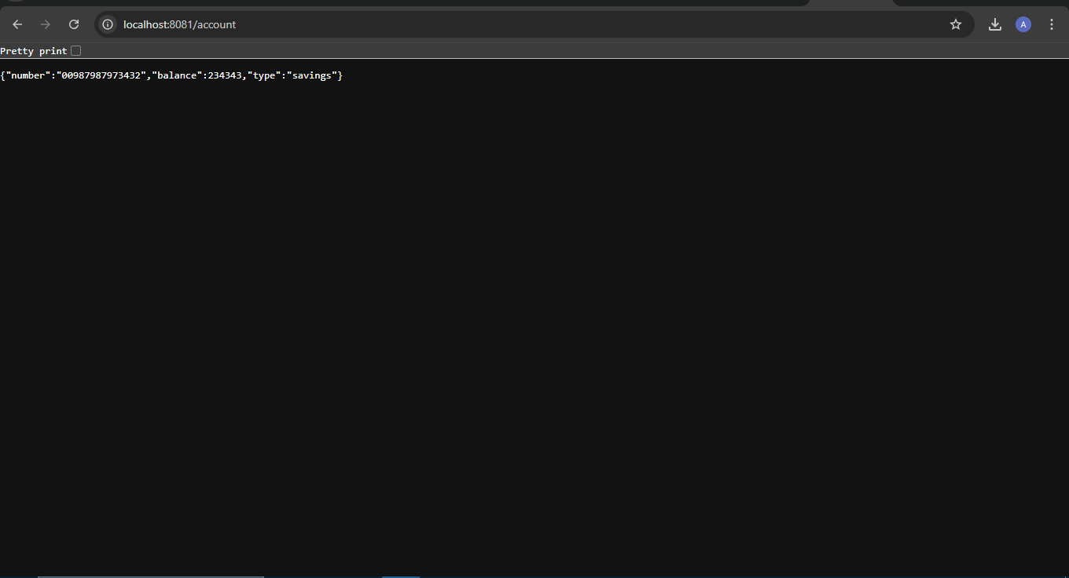

**Loan Microservice**

Pom.xml:

<project xmlns="http://maven.apache.org/POM/4.0.0"

xmlns:xsi="http://www.w3.org/2001/XMLSchema-instance"

xsi:schemaLocation="http://maven.apache.org/POM/4.0.0

http://maven.apache.org/xsd/maven-4.0.0.xsd">

<modelVersion>4.0.0</modelVersion>

<groupId>com.cognizant</groupId>

<artifactId>loan-service</artifactId>

<version>0.0.1-SNAPSHOT</version>

<packaging>jar</packaging>

<name>loan-service</name>

<description>Spring Boot Loan Microservice</description>

<properties>

<java.version>17</java.version>

<spring.boot.version>3.2.4</spring.boot.version>

</properties>

<dependencyManagement>

<dependencies>

<dependency>

<groupId>org.springframework.boot</groupId>

<artifactId>spring-boot-dependencies</artifactId>

<version>${spring.boot.version}</version>

<type>pom</type>

<scope>import</scope>

</dependency>

</dependencies>

</dependencyManagement>

<dependencies>

<dependency>

<groupId>org.springframework.boot</groupId>

<artifactId>spring-boot-starter-web</artifactId>

</dependency>

<dependency>

<groupId>org.springframework.boot</groupId>

<artifactId>spring-boot-devtools</artifactId>

<scope>runtime</scope>

</dependency>

<dependency>

<groupId>org.springframework.boot</groupId>

<artifactId>spring-boot-starter-test</artifactId>

<scope>test</scope>

</dependency>

</dependencies>

<build>

<plugins>

<plugin>

<groupId>org.springframework.boot</groupId>

<artifactId>spring-boot-maven-plugin</artifactId>

<version>${spring.boot.version}</version>

</plugin>

</plugins>

</build>

</project>

LoanServiceApplication.java:

**package** com.cognizant.loanservice;

**import** org.springframework.boot.SpringApplication;

**import** org.springframework.boot.autoconfigure.SpringBootApplication;

@SpringBootApplication

**public** **class** LoanServiceApplication {

**public** **static** **void** main(String[] args) {

SpringApplication.*run*(LoanServiceApplication.**class**, args);

}

}

LoanController.java:

**package** com.cognizant.loanservice.controller;

**import** org.springframework.web.bind.annotation.GetMapping;

**import** org.springframework.web.bind.annotation.RequestMapping;

**import** org.springframework.web.bind.annotation.RestController;

**import** java.util.HashMap;

**import** java.util.Map;

@RestController

@RequestMapping("/loan")

**public** **class** LoanController {

@GetMapping

**public** Map<String, Object> getLoanDetails() {

Map<String, Object> loan = **new** HashMap<>();

loan.put("loanNumber", "LOAN-7687878");

loan.put("type", "home");

loan.put("amount", 1000000);

**return** loan;

}

}

Web Screenshot:

